# Exercises: Conditional Statements and Loops

Problems for exercises and homework for the [“JavaScript Fundamentals” course @ SoftUni](https://softuni.bg/trainings/2080/js-fundamentals-september-2018). Submit your solutions in the SoftUni judge system at<https://judge.softuni.bg/Contests/308/Expressions-Conditional-Statements-and-Loops>.

In this homework you are supposed to **write program logic** using expressions, conditions and loops in JavaScript. You will practice working with arithmetic operators, **expressions** and calculations, using **conditional statements** (if, if-else, multiple if-else-if-else-… and switch-case) and working with **loop statements** (like for, while, do-while and for-of) and **nested loops**, combined with conditional statements and calculations.

## Biggest of 3 Numbers

Write a JS function that finds the **biggest of 3 numbers**.

The **input** comes as **array of 3 numbers**.

The **output** is the biggest from the input numbers.

### Examples

|  |  |  |  |  |  |  |  |  |  |  |  |  |  |
| --- | --- | --- | --- | --- | --- | --- | --- | --- | --- | --- | --- | --- | --- |
| **Input** | **Output** |  | **Input** | **Output** |  | **Input** | **Output** |  | **Input** | **Output** |  | **Input** | **Output** |
| [5,  -2,  7] | 7 |  | [130,  5,  99] | 130 | [43,  43.2,  43.1] | 43.2 | [5,  5,  5] | 5 | [-10,  -20,  -30] | -10 |

### Hints

Read the input and assign each number to a variable:

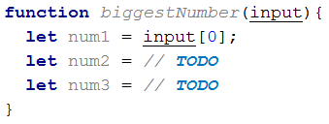

You may use Math.max(num1, num2, num3) to find the biggest number. It will automatically convert strings to numbers, so parsing the input elements to number might not be obligatory. Your code might look like this:

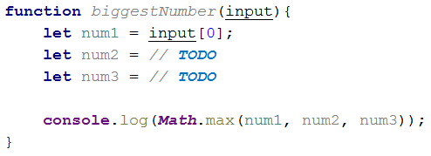

**Test** the above code **locally** by invoking the biggestNumber() function like this:

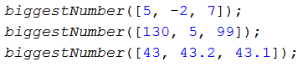

**Test** the above code **locally** in your Web browser:

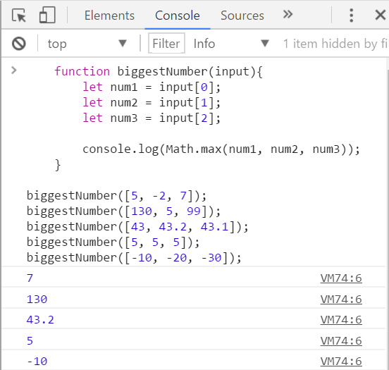

Finally, submit your code in the judge system: [https://judge.softuni.bg/Contests/308/Expressions-Conditional-Statements-and-Loops.](https://judge.softuni.bg/Contests/308/Expressions-Conditional-Statements-and-Loops)

[Note: the above code might be shortened like this:](https://judge.softuni.bg/Contests/308/Expressions-Conditional-Statements-and-Loops)

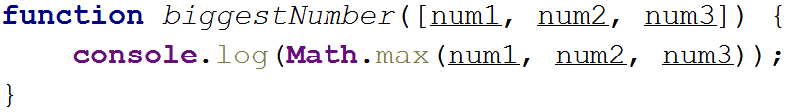

The above code takes the input as array of 3 string variables num1, num2 and num3. Then the function Math.max(…) converts its string arguments to numbers and returns the biggest of them.

You may shorten further your solution by making it an **arrow function** like the shown below:



The **judge** system will **accept** the above solution as correct.

In the judge you can also **return the expected result** instead of printing it at the console, so the following solution will also be accepted by the judge, as well:



The above code could be even further shortened like this:



The judge system will accept the above arrow function as correct solution, passing all the tests.

Enjoy!

## Point in Rectangle

Write a JS function that takes as input 6 numbers x, y, xMin, xMax, yMin, yMax and prints whether the point {x, y} is **inside** the rectangle or **outside** of it. If the point is at the rectangle **border**, it is considered **inside**.

The **input** comes as **array of numbers**. It holds the representations of x, y, xMin, xMax, yMin, yMax. All numbers will in the range [-1 000 000 … 1 000 000]. It is guaranteed that xMin < xMax and yMin < yMax.

The **output** is a single line holding “**inside**” or “**outside**”.

### Examples

|  |  |  |  |  |  |  |
| --- | --- | --- | --- | --- | --- | --- |
| **Input** | **Output** | **Figure** |  | **Input** | **Output** | **Figure** |
| [8,  -1,  2,  12,  -3,  3] | inside |  | [12.5,  -1,  2,  12,  -3,  3] | outside |  |

### Hints

First write a JS function to **read the input numbers** x, y, xMin, xMax, yMin and yMax from the array of 6 numbers, passed as input parameter input. The numbers should be taken from the array elements input[0], input[1], … as follows:

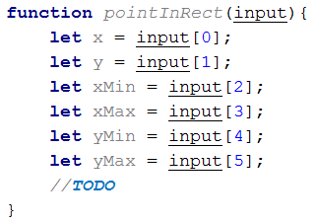

The above code could be significantly shortened by using a JS language feature called “**destructuring assignment**” like this:

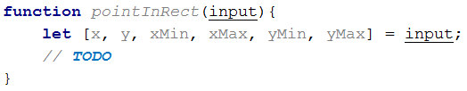

Next, write if-else statement to check whether the point {x, y} is inside the rectangle. A **point is inside a rectangle** if and only if both of the following conditions are fulfilled:

* its x coordinate is between xMin and xMax
* its y coordinate is between yMin and yMax

The code may look like this:

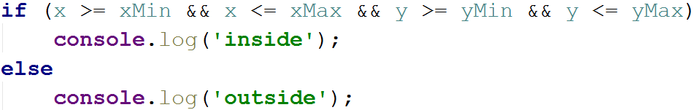

Now **test the function locally** on your computer. Invoke the above function like this:

C:\Users\Valio\AppData\Local\Microsoft\Windows\INetCache\Content.Word\f8.png

Note that the function takes its input as **6 numbers**. You may test your code in your IDE, in the console (with Node.js) or in your Web browser’s JS console.

The screenshot below shows the above function, invoked in **Chrome JavaScript Console**:

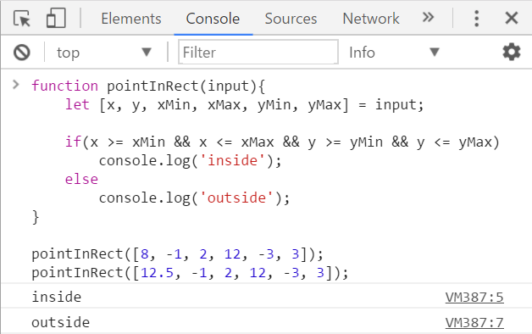

The screenshot below shows the above code in the **Node.js REPL console**:

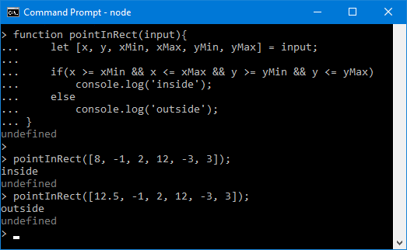

Now you are ready to submit your solution in the **judge system**. Open the judge contest for this homework and submit your code: <https://judge.softuni.bg/Contests/308/Expressions-Conditional-Statements-and-Loops>. It should look like this:

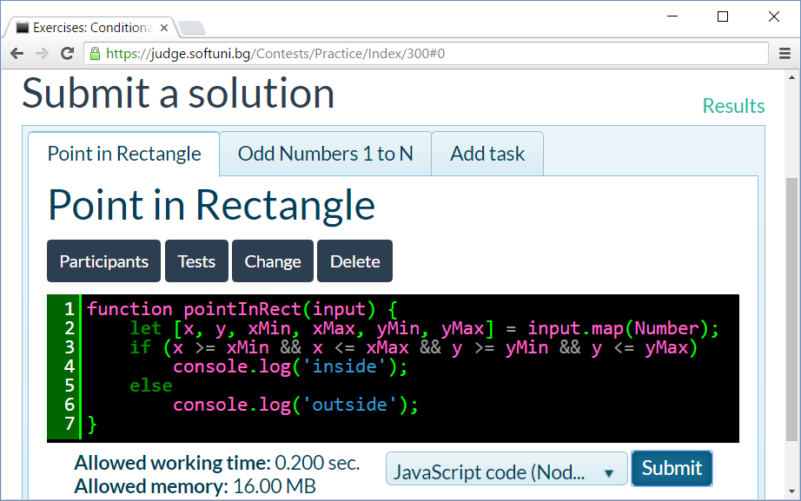

The judge system should **accept your solution** as correct:

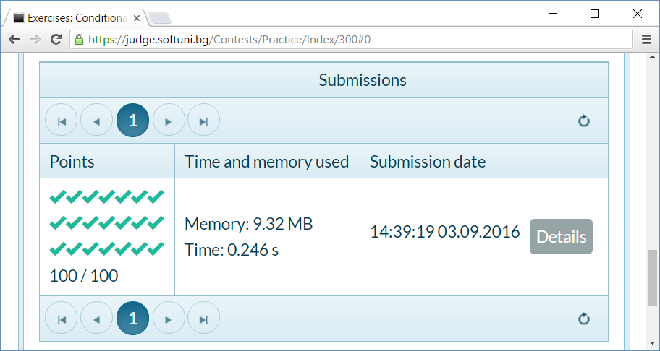

## Odd Numbers 1 to N

Write a JS function that reads an integer **n** and prints all **odd numbers** from **1** to **n**.

The **input** comes as a **single number n**. The number **n** will be an integer in the range [1 … 100 000].

The **output** should hold the expected odd numbers, each at a separate line.

### Examples

|  |  |  |  |  |  |  |  |
| --- | --- | --- | --- | --- | --- | --- | --- |
| **Input** | **Output** |  | **Input** | **Output** |  | **Input** | **Output** |
| 5 | 1  3  5 |  | 4 | 1  3 | 7 | 1  3  5  7 |

### Hints

First write a JS function to read the input number **n**.

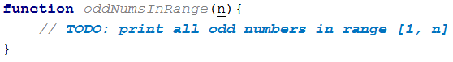

Next, write a for-loop from 1 to n with **step** 2:

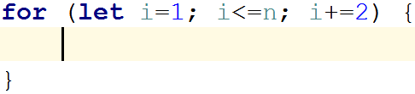

Finally, print the number i at each iteration of the for-loop. The entire function should look like this:

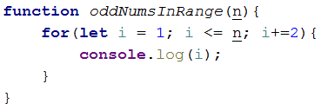

Now **test the function locally** on your computer. Invoke the above function like this:

C:\Users\Valio\AppData\Local\Microsoft\Windows\INetCache\Content.Word\fn2.png

You may test your code in the console (with Node.js) or in your Web browser’s JS console.

The screenshot below shows the above function, invoked in **Chrome JavaScript Console**:

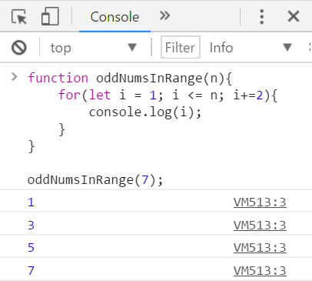

The screenshot below shows the above code in the **Node.js REPL console**:

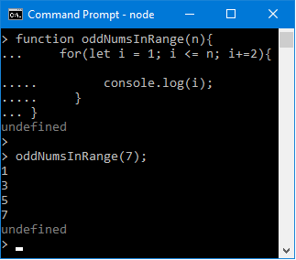

Now you are ready to submit the problem in the **judge system**. Open the judge contest for this homework and submit your code: <https://judge.softuni.bg/Contests/308/Expressions-Conditional-Statements-and-Loops>. It should look like this:

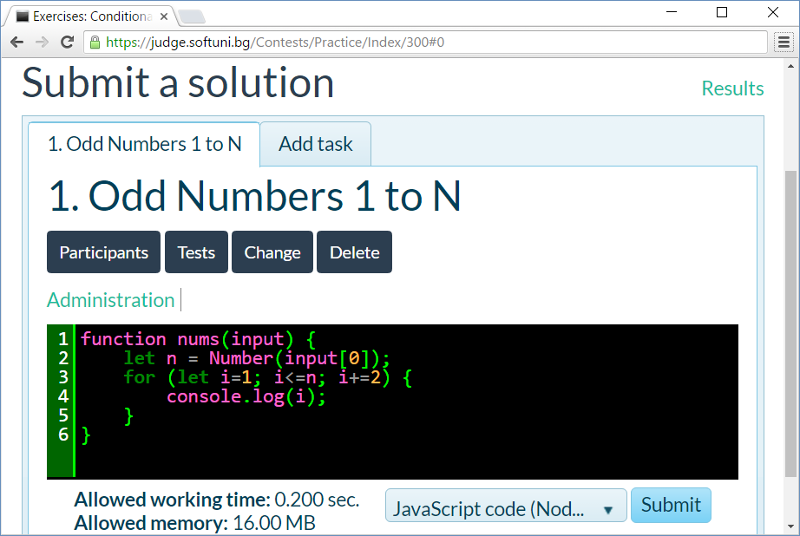

The judge system should **accept your solution** as correct:

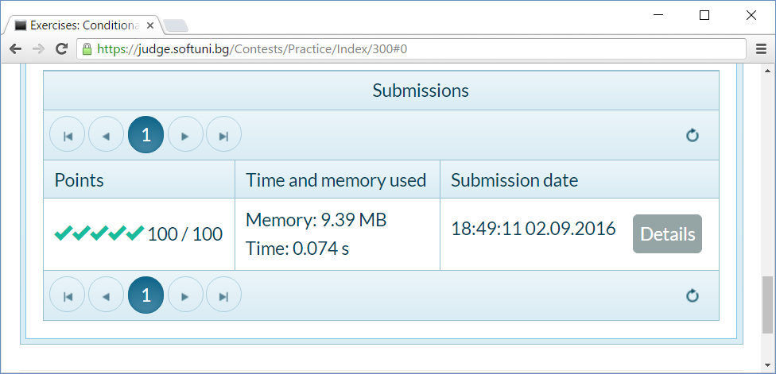

## Triangle of Dollars

Write a JS function that prints a triangle of n lines of “$” characters like shown in the examples.

The **input** comes as a **single number** n (0 < n < 100).

The **output** consists of n text lines like shown below.

### Examples

|  |  |  |  |  |  |  |  |
| --- | --- | --- | --- | --- | --- | --- | --- |
| **Input** | **Output** |  | **Input** | **Output** |  | **Input** | **Output** |
| 3 | $  $$  $$$ |  | 2 | $  $$ | 4 | $  $$  $$$  $$$$ |

### Hints

Variant 1: use **nested loops** and for each row collect the ‘$’ characters in a string and then print it:

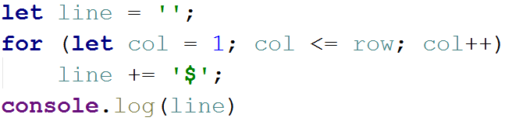

Variant 2: use a simple loop row = 1 … n and print row dollars this way:



Variant 3: you can print row dollars by **repeating** the '$' string row times:



## Movie Prices

Movie ticket **prices** in a big retro-cinema depend on the **movie title** and on the **day of week** as shown below:

|  |  |  |  |  |  |  |  |
| --- | --- | --- | --- | --- | --- | --- | --- |
| ***Movie Title*** | ***Monday*** | ***Tuesday*** | ***Wednesday*** | ***Thursday*** | ***Friday*** | ***Saturday*** | ***Sunday*** |
| **The Godfather** | 12 | 10 | 15 | 12.50 | 15 | 25 | 30 |
| **Schindler's List** | 8.50 | 8.50 | 8.50 | 8.50 | 8.50 | 15 | 15 |
| **Casablanca** | 8 | 8 | 8 | 8 | 8 | 10 | 10 |
| **The Wizard of Oz** | 10 | 10 | 10 | 10 | 10 | 15 | 15 |

Write a JS function that **calculate the ticket price** by movie title and day of week.

The **input** comes as **array of 2 strings**. The first string holds the **movie title**. The second string holds the **day** **of week**.

The **output** should hold the **ticket price** or “**error**” if the title or day of week is invalid.

### Examples

|  |  |  |  |  |  |  |  |  |  |  |
| --- | --- | --- | --- | --- | --- | --- | --- | --- | --- | --- |
| **Input** | **Output** |  | **Input** | **Output** |  | **Input** | **Output** |  | **Input** | **Output** |
| ['The Godfather',  'Friday'] | 15 | ['casablanca',  'sunday'] | 10 | ['Schindler's LIST',  'monday'] | 8.50 | ['SoftUni',  'Nineday'] | error |

### Hints

* Turn all input values to **lowercase** to avoid character casing mistakes.
* **Check the movie title** in if-else-if statement.
* For each movie title check the price in a switch-case.
* Beware of **invalid** movie titles and invalid days of week. Show “**error**” in such cases.

You may follow the **code example** below:

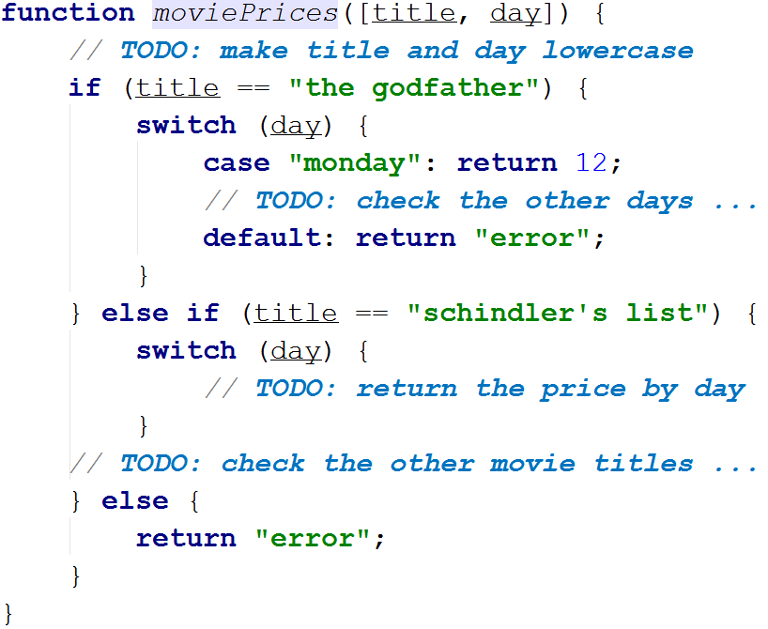

You may **test your code** locally like this:

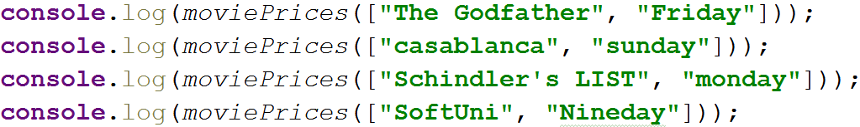

## Quadratic Equation

Write a JS function to **solve a quadratic equation** by given in standard form as its coefficients: **a**, **b**, **c**. You may learn more about quadratic equations here: <https://www.mathsisfun.com/algebra/quadratic-equation.html>.

The **input** comes as **3 numbers** **a**, **b** and **c**. The value of a will be non-zero.

The **output** depends on the equation:

* It holds two numbers x1 and x2 if the equation has two different solutions (roots): x1 and x2.
  + First print the smaller root, then the greater.
* It holds a single number x if the equation has only one solution (root): x.
* It holds the text “No” if the equation has no solutions (no real roots).

### Examples

|  |  |  |
| --- | --- | --- |
| **Input** | **Output** | **Comments** |
| 6, 11, -35 | -3.5  1.66667 | The equation is: 6*x*2 + 11*x* - 35 = 0 → *a* = 6; *b* = 11; *c* = -35  The discriminant is: *d* = *b*2 - 4\**a*\**c* = 11*11 - 4*6*(-35) = 121 + 840 = 961  We have positive discriminant (*d* > 0), so the equation has two real roots:   * x1 = (-*b* + √*d*) / (2\**a*) = (-11 + 31) / 12 = 20/12 = 5/3 ≈ 1.66667 * x2 = (-*b* - √*d*) / (2\**a*) = (-11 - 31) / 12 = -42/12 = -7/2 = -3.5   The output consists of two lines:   * -3.5 (the smaller root at the first line) * 1.66667 (the bigger root at the second line) |
| 1, -12, 36 | 6 | The equation is: *x*2 - 12*x* + 36 = 0 → *a* = 1; *b* = -12; *c* = 36  The discriminant is: *d* = *b*2 - 4\**a*\**c* = -12*-12 - 4*1*36 = 144 - 144 = 0  We have zero discriminant (*d* = 0), so the equation has only one real root:   * x = -*b* / (2\**a*) = 12 / 2 = 6   The output is only one line, holding the number 6. |
| 5, 2, 1 | No | The equation is: 5*x*2 - 2*x* + 1 = 0 → *a* = 5; *b* = -2; *c* = 1  The discriminant is: *d* = *b*2 - 4\**a*\**c* = -2*-2 - 4*5*1 = 4 - 20 = -16  We have negative discriminant (*d* < 0), so the equation has no real roots.  The output is only one line, holding the text “No”. |

### Hints

* Search for “***solving quadratic equation***” in Internet.
* Use if-conditions and expressions to calculate the **discriminant** and the equation **roots** (if any).

## Multiplication Table

Write a JS function to print a **math multiplication table** of size n, formatted as **HTML table**.

The **input** comes as a single number n (0 < n < 100).

The **output** consists of n+3 text lines like shown below.

### Examples

|  |  |
| --- | --- |
| **Input** | 5 |
| **Output** | <table border="1">  <**tr**><th>**x**</th><th>**1**</th><th>**2**</th><th>**3**</th><th>**4**</th><th>**5**</th></**tr**>  <**tr**><th>**1**</th><td>**1**</td><td>**2**</td><td>**3**</td><td>**4**</td><td>**5**</td></**tr**>  <**tr**><th>**2**</th><td>**2**</td><td>**4**</td><td>**6**</td><td>**8**</td><td>**10**</td></**tr**>  <**tr**><th>**3**</th><td>**3**</td><td>**6**</td><td>**9**</td><td>**12**</td><td>**15**</td></**tr**>  <**tr**><th>**4**</th><td>**4**</td><td>**8**</td><td>**12**</td><td>**16**</td><td>**20**</td></**tr**>  <**tr**><th>**5**</th><td>**5**</td><td>**10**</td><td>**15**</td><td>**20**</td><td>**25**</td></**tr**>  </table> |
| **Preview** |  |

### Hints

* Create a function multiplicationTable(n) { … }. It will return a table of size n.
* First, print the “<table border='1'>” opening tag.
* Using a simple loop, print the **heading row**.
  + It should hold <tr> + “x” + the numbers 1…n (all surrounded in <td></td>) + </tr>.
* Print the **next** n **lines** using nested loops.
  + For each line start with <tr>, then append its elements in a loop (all surrounded in <td></td>) and finally append </tr>.
* After the loops, at the end, print the “</table>” closing tag.
* You may visualize your code’s output in the browser like this:

C:\Users\Valio\AppData\Local\Microsoft\Windows\INetCache\Content.Word\fn5.png

## Figure of 4 Squares

Write a JS function to print a **figure of 4 squares** of size n like shown in the examples below.

The **input** is an integer number n in the range [2 … 200].

The **output** consists of n lines for **odd** n and n-1 lines for even n. Each line holds 2*n-1 characters (+ or | or ***space***) as shown in the examples. The figure is fully symmetric (horizontally and vertically).

### Examples

|  |  |  |  |  |  |  |  |  |  |  |
| --- | --- | --- | --- | --- | --- | --- | --- | --- | --- | --- |
| **Input** | **Output** |  | **Input** | **Output** |  | **Input** | **Output** |  | **Input** | **Output** |
| 4 | +--+--+  +--+--+  +--+--+ | 5 | +---+---+  | | |  +---+---+  | | |  +---+---+ |  | 6 | +----+----+  | | |  +----+----+  | | |  +----+----+ | 7 | +-----+-----+  | | |  | | |  +-----+-----+  | | |  | | |  +-----+-----+ |

### Hints

* Use **nested loops** and if-statements. Try to figure out the **logic of construction** of the above figures.

## ** Monthly Calendar

Note: this problem is for champions only!

Write a JS function calendar([day, month, year]) that returns a **monthly calendar as HTML** **table** (like in the examples below) by given **day**, **month** and **year**. Weeks start by “**Sun**” (Sunday) and end by “**Sat**” (Saturday).

The **input** comes as array of 3 numbers:

* day (1 ≤ day ≤ 31)
* month (1 ≤ month ≤ 12)
* year (1900 ≤ year ≤ 2100)

The **output** should be an **HTML table**, holding the calendar rows and columns, like in the examples below. Display the **weeks** as table rows: <tr>…</tr>. Display the **days** as table cells: <td>…</td>. Display the days of the previous month with CSS class “**prev-month**”, the days of the next month with CSS class “**next-month**” and the current day with CSS class “today”. See the examples below.

### Examples

|  |  |
| --- | --- |
| **Input** | [24, 12, 2012] |
| **Output** | <table>  <tr><th>**Sun**</th><th>**Mon**</th><th>**Tue**</th><th>**Wed**</th><th>**Thu**</th><th>**Fri**</th><th>**Sat**</th></tr>  <tr><td class="**prev-month**">**25**</td><td class="**prev-month**">**26**</td><td class="**prev-month**">**27**</td><td class="**prev-month**">**28**</td><td class="**prev-month**">**29**</td><td class="**prev-month**">**30**</td><td>**1**</td></tr>  <tr><td>**2**</td><td>**3**</td><td>**4**</td><td>**5**</td><td>**6**</td><td>**7**</td><td>**8**</td></tr>  <tr><td>**9**</td><td>**10**</td><td>**11**</td><td>**12**</td><td>**13**</td><td>**14**</td><td>**15**</td></tr>  <tr><td>**16**</td><td>**17**</td><td>**18**</td><td>**19**</td><td>**20**</td><td>**21**</td><td>**22**</td></tr>  <tr><td>**23**</td><td class="**today**">**24**</td><td>**25**</td><td>**26**</td><td>**27**</td><td>**28**</td><td>**29**</td></tr>  <tr><td>**30**</td><td>**31**</td><td class="**next-month**">1</td><td class="**next-month**">**2**</td><td class="**next-month**">**3**</td><td class="**next-month**">**4**</td><td class="**next-month**">**5**</td></tr>  </table> |
| **Preview** |  |

|  |  |
| --- | --- |
| **Input** | [4, 9, 2016] |
| **Output** | <table>  <tr><th>**Sun**</th><th>**Mon**</th><th>**Tue**</th><th>**Wed**</th><th>**Thu**</th><th>**Fri**</th><th>**Sat**</th></tr>  <tr><td class="**prev-month**">**28**</td><td class="**prev-month**">**29**</td><td class="**prev-month**">**30**</td><td class="**prev-month**">**31**</td><td>**1**</td><td>**2**</td><td>**3**</td></tr>  <tr><td class="**today**">**4**</td><td>**5**</td><td>**6**</td><td>**7**</td><td>**8**</td><td>**9**</td><td>**10**</td></tr>  <tr><td>**11**</td><td>**12**</td><td>**13**</td><td>**14**</td><td>**15**</td><td>**16**</td><td>**17**</td></tr>  <tr><td>**18**</td><td>**19**</td><td>**20**</td><td>**21**</td><td>**22**</td><td>**23**</td><td>**24**</td></tr>  <tr><td>**25**</td><td>**26**</td><td>**27**</td><td>**28**</td><td>**29**</td><td>**30**</td><td class="**next-month**">**1**</td></tr>  </table> |
| **Preview** |  |

### HTML Skeleton

To simplify your work, use the below HTML code and write the missing code in the calendar() function:

|  |
| --- |
| **calendar.html** |
| <!DOCTYPE html> <**html**> <**head**>  <**title**>Monthly Calendar</**title**>  <**style**>  .**prev-month**, .**next-month** { color: **#CCC** }  .**today** { font-weight: **bold**; background: **#DDD**; }  .**title** { background: **#AAAAFF**; margin: 10**px 0**; padding:5**px** }  **table** { border: 1**px solid #CCC**;}  **td** { text-align: **center**; }  **#calendarCode** { width: 100%; }  </**style**>  <**script**>  **function** *calendar*([day, month, year])  {  *//* ***TODO: return the HTML text holding the calendar table***  }  </**script**> </**head**>  <**body**>  Day: <**input** id=**"day"** type=**"number"** value=**"4"** />  Month: <**input** id=**"month"** type=**"number"** value=**"9"** />  Year: <**input** id=**"year"** type=**"number"** value=**"2016"** />  <**input** type=**"button"** value=**"Show"** onclick=**"let *calendarHTML*** =  *calendar*([**document**.getElementById(**'day'**).**value**,  **document**.getElementById(**'month'**).**value**,  **document**.getElementById(**'year'**).**value**]);  **document**.getElementById(**'calendar'**).**innerHTML** = ***calendarHTML***;  **document**.getElementById(**'calendarCode'**).**innerText** = ***calendarHTML*"** />  <**div** class=**"title"**>Calendar:</**div**>  <**div** id=**"calendar"**>Calendar will be shown here</**div**>  <**div** class=**"title"**>HTML:</**div**>  <**textarea** rows=**"12"** id=**"calendarCode"**></**textarea**> </**body**>  </**html**> |

Submit in the **judge system** the JS code of your calendar() function only, without the above HTML code that visualizes the calendar in the Web browser.

### Screenshot

This is how your calendar should look in Web browser, when the calendar() function is implemented correctly:

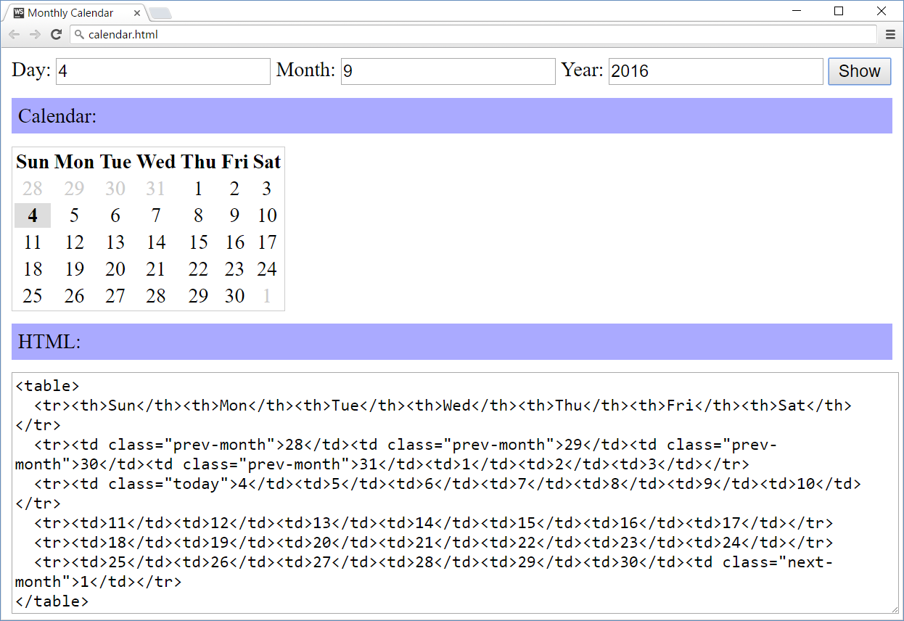

### Hints

* Printing a calendar in JS without using an external library is not as simple as the previous problems in this exercise! It may take a few hours or even more to implement it correctly.
* Play with the class [**Date**](https://developer.mozilla.org/en-US/docs/Web/JavaScript/Reference/Global_Objects/Date) in JavaScript and make some calculations.
* You may also search in Google, e.g. try “JavaScript calendar code example”.
* Print the calendar table **headings** + days.
* Print the days from the **previous month** (if any).
  + Find the day of week for the first day of the input date.
  + If it is not Sunday, days from the previous month exist.
  + Go back a few days in the previous month to find the closest Sunday (first week day).
  + Start from it and print the days until the end of the previous month.
* Print the days from the **current month**.
  + Print the days, one after another.
  + Create a new table row after the last week day (Saturday).
* Print the days from the **next month** (if any).
  + Stop when you reach Saturday (the last week day).
* You may start from this code template:

